**Lab – 22**

**Student Name: Navneet P**

**Student ID: AF0411619**

***Topic: Matplotlib Bar Plot and Histogram***

**Bar Plots:**

A bar plot uses bars to represent each category or subcategory, with the length of the bar corresponding to the numeric value. The categorical variable is plotted on one axis, and the numeric value is plotted on the other axis. Bar plots are a common and simple way to compare objects with the same parameters. They can help audiences understand the insights and ideas suggested by the data.

1. **Vertical Bar Plots:** Verticalbar plots represent the data vertically. These are bar graphs whose bars are drawn vertically.
2. **Horizontal Bar Plots**: Horizontalbar graphs represent the data horizontally. These are sideways bar graphs whose bars are drawn horizontally.

Functions used in this assignment:

1. **Bar():** a much more elaborate way to specify xlabels, ylabels, colors, bar labels, is often used when subplots are created initially.
2. **Bar_label():** a much more simpler method to directly add labels to the bars and customize its features such as font size, bar edge color etc.
3. **Stem():** Creates a stem plot, it plots vertical lines from a baseline to the y-coordinate and places a marker at the tip.
4. **Barh():** Creates a horizontal bar plot
5. **Hist():** Creates a histogram which is used to plot continuous values.

**Example 1:** Small Demo on adding some data labels.

Solution:

We could create subplots and use the bar() method to add labels or we could use the latest bar_label() method which is a liitle easier to implement. [Ref](https://matplotlib.org/stable/gallery/lines_bars_and_markers/bar_label_demo.html#sphx-glr-gallery-lines-bars-and-markers-bar-label-demo-py)

Code:

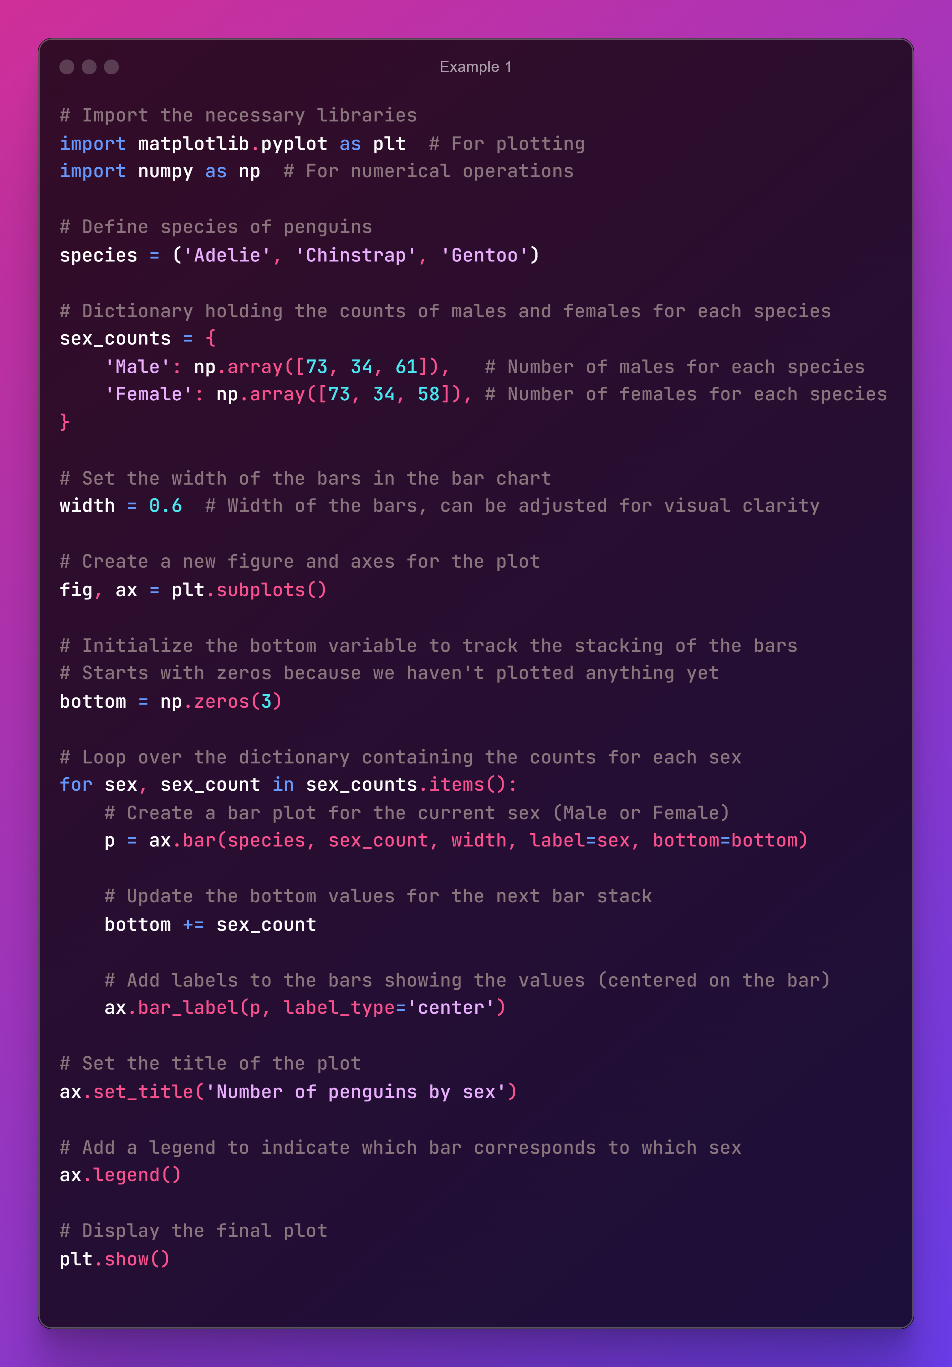

Output:

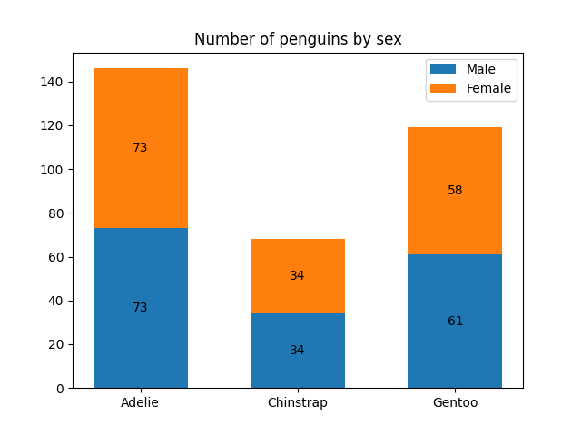

**Example 2:** Creating a stem plot

Solution:

A stem plot plots vertical lines from a baseline to the y-coordinate and places a marker at the tip. [Ref](https://matplotlib.org/stable/gallery/lines_bars_and_markers/stem_plot.html#sphx-glr-gallery-lines-bars-and-markers-stem-plot-py)

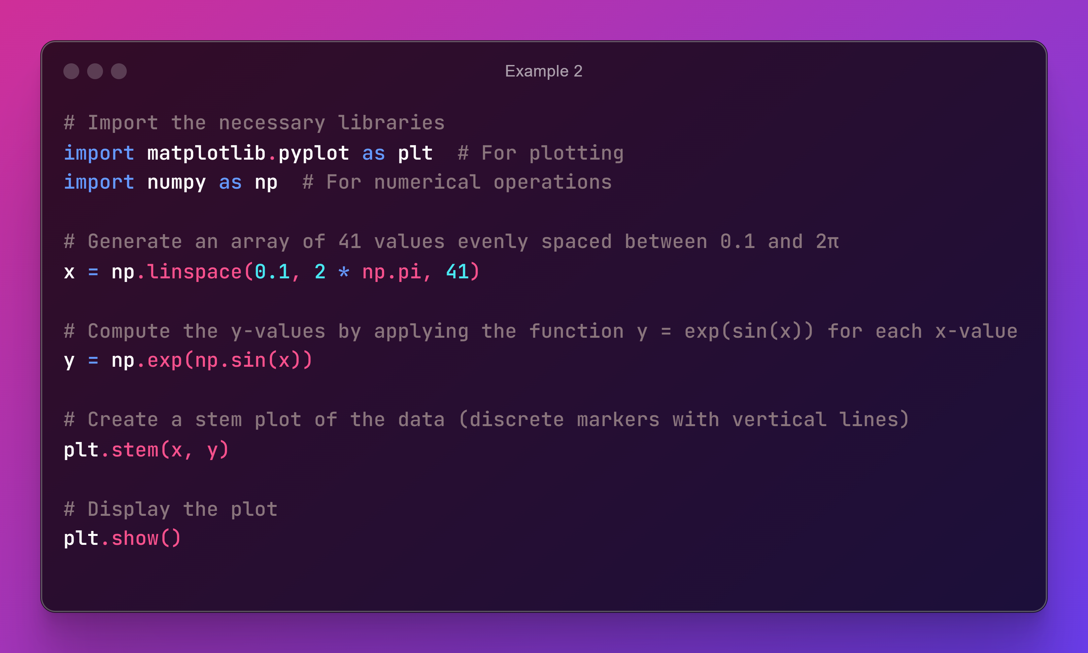

Output:

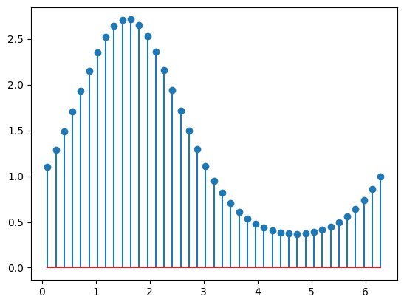

Q1. Visualize daily temperature in a specific location.

Solution:

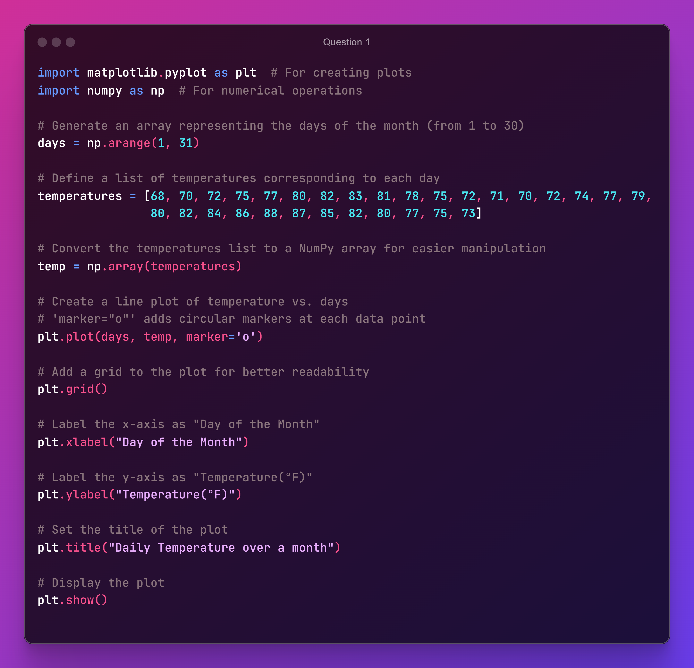

Output:

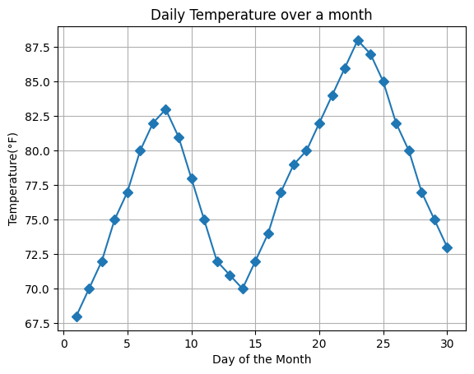

Q2. Visualize the number of books sold in a bookstore by genre over a year.

Solution:

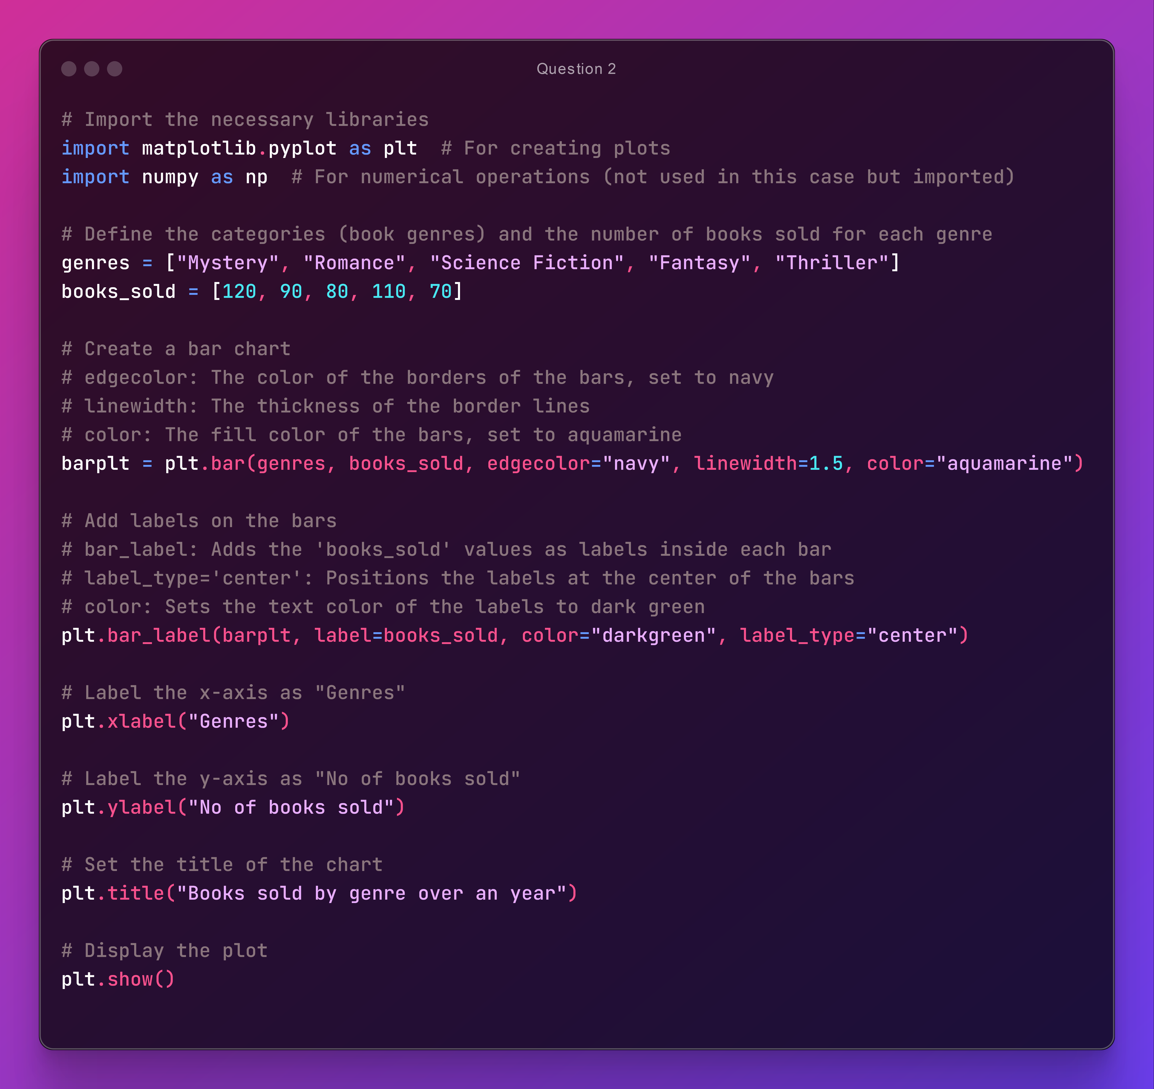

Output:

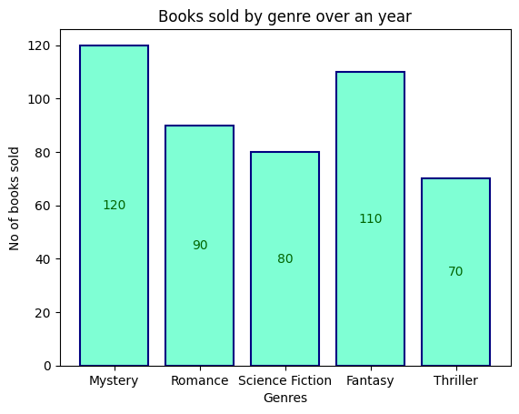

Q3. Horizontal Bar Plot in Python over age groups and population.

Solution: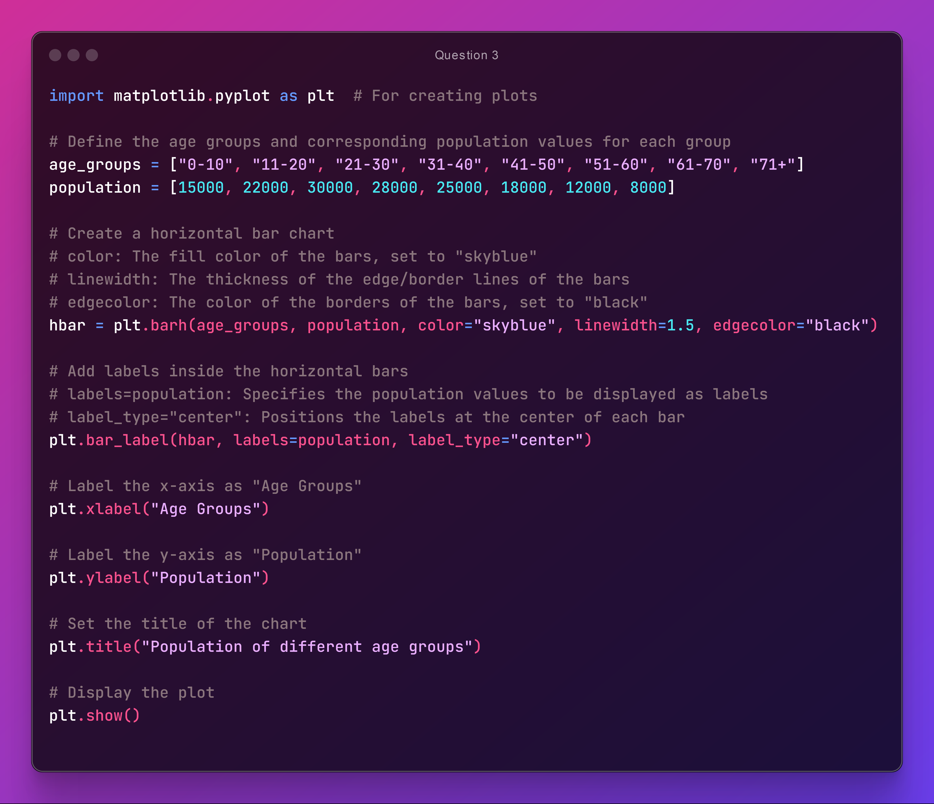

Output:

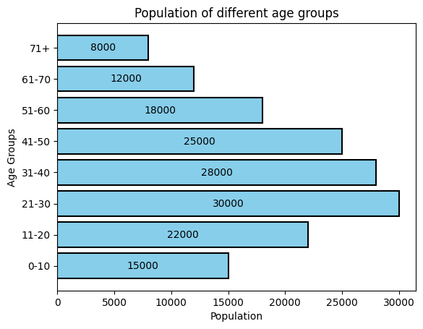

Q4. Histogram of Ages of Survey Respondents.

Solution:

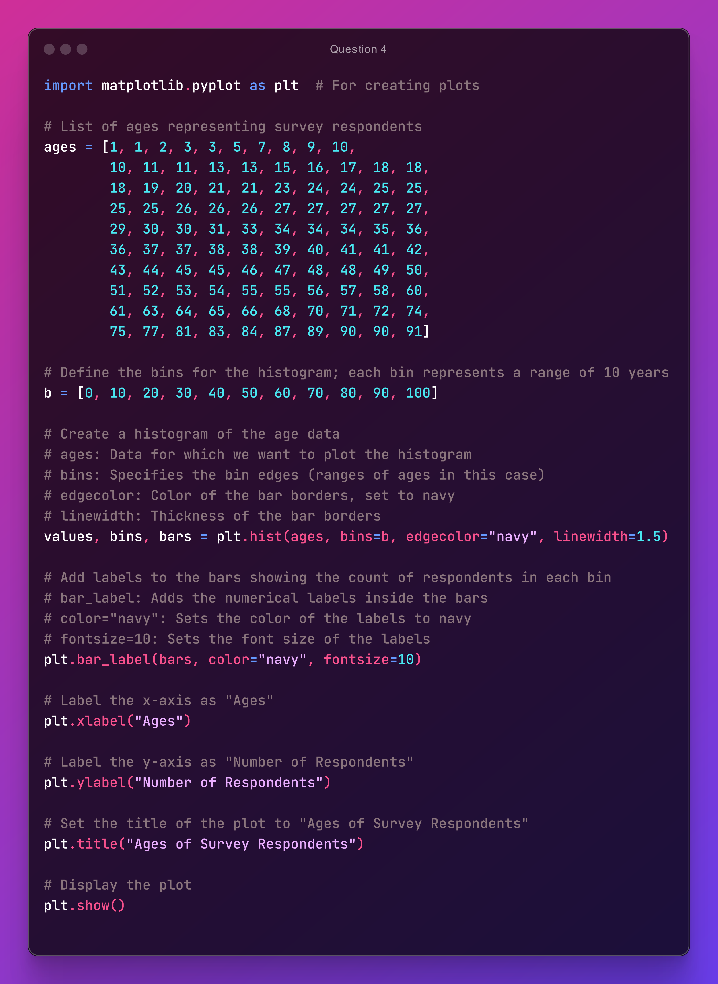

Output:

